**Burn Severity and Vegetation Recovery Analysis**

**of the Anaktuvuk River Fire**

**on the North Slope Tundra of Alaska**

**J. A. Strzempko**

**May 2020**

**A Thesis**

**Submitted to faculty of Clark University,**

**Worcester, Massachusetts, in partial fulfillment of**

**the requirements for the degree of Arts**

**in the Department of Geography**

**THESIS COMMITTEE**

Karen Frey, Ph.D.

Chief Instructor

John Rogan, Ph.D.

Committee Member

**ABSTRACT**

Despite their historical rarity, tundra wildfires on the Alaskan North Slope are projected to increase in a trend driven by altered climatic conditions. The Anaktuvuk River Fire of 2007, the largest recorded tundra fire, offers the opportunity to study long-term post-fire vegetation recovery dynamics as a function of burn severity. A combination of multi-spectral indices is applied for the information they provide and utility in comparison. The use of satellite-based data for burn severity and vegetation recovery analysis is ideal owing to the remote location and inaccessibility of the burn site. Normalized Burn Ratio and Normalized Difference Vegetation Index were derived from Landsat imagery, while Enhanced Vegetation Index was sourced from Moderate Resolution Imaging Spectroradiometer imagery.

All indices demonstrated rapid vegetation recovery of total burn scar immediately post-fire, followed by slower subsequent recovery. A return of vegetation health to unburned levels was observed in EVI and not NDVI nor NBR, perhaps owing to the low temporal resolution of the acquired Landsat imagery. Within individual observations of severity classes, moderately burned areas recovered at the fastest rate from 1 to 2 years post-fire across all indices. Additionally, significant differentiation (α = 0.05) between unburned regions and moderately and highly burned areas in all indices persisted 10+ years post-fire. Possible long-term dynamics signal high and moderately burned vegetation generate conditions conducive to tundra community development as indicated by satellite-based metrics.

**© 2020**

**JESSICA A. STRZEMPKO**

**ALL RIGHTS RESERVED**

**ACADEMIC HISTORY**

**Name: Jessica Anne Strzempko Date: May 2020**

**Baccalaureate Degree: Bachelor of Arts**

**Source: Clark University Date: May 17, 2020**

**ACKNOWLEDGEMENTS**

I would like to thank Professor Karen Frey, Associate Professor in the Graduate School of Geography at Clark University, for being an incredibly kind and supportive advisor throughout my entire undergraduate career. Additionally, a huge thank you to Professor John Rogan in the Graduate School of Geography at Clark University for his advice and guidance during many steps of the process, particularly topic development, data acquisition, and analysis. Thank you also to my roommates and friends for cheering me along. My biggest thank you goes to my family for loving and listening to me always. I wouldn’t be able to achieve my goals without you all.

**TABLE OF CONTENTS**

List of Figuresviii

List of Tablesiv

Introduction1

Anaktuvuk River Fire2

Remote Sensing of Fires3

Study Purpose5

Methods6

Results9

Severity Designations9

Normalized Burn Ratio10

Normalized Difference Vegetation Index11

Enhanced Vegetation Index13

Discussion14

Conclusion19

Bibliography20

Appendix24

**LIST OF FIGURES**

Figure 1. North Slope of Alaska with historical fire perimeters27

Figure 2. True color composites of the study area before and after the ARF28

Figure 3. False color composites of the study area before and after the ARF29

Figure 4. Differenced Normalized Burn Ratio (dNBR) image30

Figure 5. Analysis regions chosen for Landsat and MODIS analysis 31

Figure 6. Images of Landsat NBR values32

Figure 7. Graph of Landsat NBR values33

Figure 8. Images of Landsat NDVI values34

Figure 9. Graph of Landsat NDVI values35

Figure 10. Graph of MODIS EVI values36

**LIST OF TABLES**

Table 1. Dates of image collection for Landsat imagery24

Table 2. Burn severity classification24

Table 3. T-statistics for NBR (α = 0.05)25

Table 4. T-statistics for NDVI (α = 0.05)25

Table 5. T-statistics for EVI (α = 0.05) 26

**INTRODUCTION**

As a mode of disturbance, wildfires are critical to a variety of landscapes, shaping natural patterns of productivity, regeneration, and regrowth. Despite commonalities across landscapes in terms of human impact, the ecological dynamics of wildfires tend to vary with ecotypes. In the Arctic, dominated by the tundra and boreal biomes, wildfires have been a historical rarity until recent decades (Wein, 1976). As the global impacts of climate change grow, the Arctic is experiencing unprecedented climatic conditions. Arctic sea ice decline is contributing to amplification of surface warming as warmer sea surface temperatures lead to warmer air masses moving inland, drying out biomass and altering terrestrial dynamics (Bhatt et al., 2014). Based on historical data of tundra-fire regimes, it is predicted that changing land temperatures will encourage growth of shrub-dominated tundra, increasing fuel load and fire activity (Higuera et al., 2008; Hu et al., 2015). Knowledge and monitoring of these modified regimes will remain critical for future fire management in regard to wildlife concerns, human health and extractive industry impacts, and contributions to global carbon fluxes.

During the largest recorded Alaskan fire season in 2004, over 6 million acres burned more land than that of the conterminous United States during the same fire season (BLM-AFS, 2020). Since then, 4 fire seasons – 2005, 2009, 2015, and now 2019 – have exceeded the 2-million-acre mark where previously only 10 fire seasons since 1940 had done so (BLM -AFS, 2020). Alaskan wildfires are unique in that they can burn unnoticed for many days owing to their inaccessibility and remote location. The U.S. Environmental Protection Agency designated Alaskan wildfires as unmanaged and unmanageable in 2007, meaning the disturbance regime is poorly understood and difficult to effectively control (U.S. EPA, 2007). It is evident that Alaskan wildfires are distinctive in their duration, extent, and intensity.

While tundra ecosystems cover a large portion of the Alaskan North Slope on the northern slope of the Brooks Range, fewer wildfires occur on the tundra coastal plain than in interior boreal forests farther south (Wendler et al., 2011). Paleoecological evidence has shown that the abundance of tundra wildfires in recent decades is unprecedented and potentially suggests an emerging climatic feedback with wildfire proliferation sparked by warm and dry summer conditions (Hu et al., 2010). Climate change is expected to have more drastic impacts on the Arctic than lower latitudes, including lengthening growing seasons, increasing vegetation production, and decreasing snowpack (Serreze et al., 2000; Stow et al., 2004). Additionally, warming trends can lead to permafrost melting and altered species composition through the encroachment of shrub into graminoid-dominated tundra (Schurr et al., 2007). The accumulation of factors results in a larger fuel load on the Alaskan tundra with the potential to burn more intensely for longer periods of time.

*Anaktuvuk River Fire*

In 2007, the Anaktuvuk River Fire (ARF) burned 103,000 hectares on the Alaskan North Slope for almost 3 months after its detection on July 16th (Jones et al., 2009). The fire was bounded by the Itkillik River to the east and by the Anakuvuk and Nanushuk Rivers to the west, remaining between 68º 5’ and 69⁰ 3’ degrees longitude (Kolden, 2010). The fire burned mostly tussock tundra, known officially as dwarf shrub by the National Land Cover Database (NLCD). Arctic tussocks are formed primarily of grasses, sedges, and forbs with intermittent dwarf shrubs, while mountains and valleys are populated by lichen, mosses, shrubs, and sedges (ADFG; Viereck et al., 1992). The fire burned through the tundra’s period of peak phenology in late July to early August with particularly intense spread occurring in early September during an unprecedented drought late in the season (Jones et al., 2009). The ARF remains the largest tundra fire ever recorded. Quantifying the impact of burn severity on vegetation recovery will allow greater understanding of the long-term effects of fire on tundra vegetation.

*Remote Sensing of Fires*

It is desirable to use remotely sensed data to assess fire impacts as spectral imagery allows the user to distinguish natural phenological change from changes precipitated by fire disturbance. Furthermore, use of satellite-based data expands temporal and spatial access for users and is particularly useful for analysis of widescale disturbance events. In utilizing remotely sensed data to assess post-fire impacts, ground observations should be used when possible to calibrate the approach (Allen & Sorbel, 2008). Grounding remotely sensed data in field observations such as Composite Burn Index (CBI) plots ensures accurate conclusions and reduces inherent errors of image selection, seasonality, spatial resolution, and sensor combinations (Boelman et al., 2011; Y. Chen et al., 2020; Kolden, 2010). This standard was unable to be met in this study owing to its use of a time series spanning 10+ years, however, verification of results with relevant research was used when possible. Additionally, unique challenges exist when collecting satellite data on the Anaktuvuk River Fire: primarily, an extremely short growing season of 2–4 months with high cloud cover (Kolden, 2010).

Spectral indices have been used widely in fire severity assessment as comparisons provide a variety of information on vegetation health post-fire and aid in detection of burn scars (Cocke et al., 2005; Conard et al., 2002; Escuin et al., 2008; Lutz et al., 2011). In particular, Differenced Normalized Burn Ratio (dNBR) is a commonly used assessment of burn severity that incorporates imagery immediately pre- and post-fire. NBR integrates near infrared and shortwave infrared bands into an algorithm that captures aboveground biomass consumption where near infrared is sensitive to leaf moisture content and shortwave infrared is sensitive to biomass volume (Key & Benson, 2006). Epting et al. (2005) demonstrated that of all the indices analyzed for interior Alaska at 13 sites, NBR correlated most closely with the CBI plots in forested areas. This relationship did not extend to non-forested regions such as woodland, scrub, or herb land cover classes suggesting differing dynamics in tundra ecosystems.

As a representative large-scale tundra fire, the Anaktuvuk River Fire has been researched widely and used to assess burn severity measures for Alaskan tundra ecotypes (Jones et al., 2009; Kolden & Rogan, 2013). These studies have found strong correlation between ground observations of CBI plots and subsequent dNBR calculations, proving the validity of this spectral index in this region.

While spectral indices like dNBR can be used to spatially designate burn severity classes, they also provide important information on vegetation health post-fire (Boelman et al., 2011). Among the most commonly used indices to assess vegetation recovery post-fire are Normalized Difference Vegetation Index (NDVI), Enhanced Vegetation Index (EVI), and NBR. NDVI uses the visible red and near infrared bands of remotely sensed imagery to produce an index that indicates vegetation health as a measure of chlorophyll content. EVI is an extended version of NDVI that uses the blue band and additional coefficients to account for background canopy and aerosol influences. Use of these indices to study vegetation recovery has generated varied results. Studies in the conterminous U.S. (Chen et al., 2011; Yang et al., 2017) find that NDVI and EVI values correlate highly with CBI scores for the first two years post-fire, while other studies in the Alaskan tundra have shown weak, non-significant correlation between NDVI values and CBI scores (Kolden, 2010). Inconsistent conclusions regarding the most appropriate and accurate spectral indices to use to study burn severity and vegetation recovery per ecotype drive this study here.

*Study Purpose*

Primarily, this study aims to observe trends in vegetation recovery at the site of the Anaktuvuk River Fire for up to 12 years post-fire through a set of various spectral indices. Based on information derived from these indices, what is the relationship between burn severity and vegetation recovery? Furthermore, does a significant long-term difference in vegetation recovery exist between severity classes after a decade? And lastly, this study plans to compare the relevant indices – NBR, NDVI, and EVI – insofar as determining if their findings on dynamics of vegetation recovery are consistent.

**METHODS**

Annual Landsat images were selected according to minimal cloud cover over the fire perimeter and optimal timing during the short Alaskan growing season (June – August; ideally July). Several years did not contain images that met the criteria and were thus omitted. A full list of dates and associated satellites and sensors can be found in Table 1. True color and false color composites pre- and post-fire were produced to visualize the fire extent and examine the burn surface for evident heterogeneity. True color composites were created with bands 3, 2, and 1 for Landsat 5 imagery and bands 4, 3, and 2 for Landsat 8 imagery. False color composites were generated to highlight vegetation loss and thus included the infrared band (band 4 for Landsat 5 and band 5 for Landsat 8) and excluded the blue band.

For all years with Landsat imagery, a Normalized Burn Ratio Index was derived:

$$NBR=\frac{NIR-SWIR}{NIR+SWIR}$$

Band designations for near infrared (NIR) and shortwave infrared (SWIR) wavelengths were bands 4 and 7 respectively for Landsat 5 and bands 5 and 7 for Landsat 8. ∆NBR (or dNBR) was produced with pre- and post-fire imagery to create an image of burn severity and generate severity levels for analysis. Negative values indicated increasingly severe burn conditions while positive values indicated regions of no burn or vegetation regrowth. Images used were collected 2 years pre-fire (June 15th, 2005) and 1 year post-fire (June 14th, 2008) as a result of previously mentioned limitations.

$$ΔNBR=(pre-fire NBR) – (post-fire NBR)$$

Ranges of dNBR values were separated into severity classes according to guidelines proposed by the United States Geological Survery (USGS) with pixels inside the burn scar each receiving a label of either low, moderate, or high burn severity (Table 2). The burned area polygon from the Moderate Resolution Imaging Spectroradiometer (MODIS) did not provide sufficient spatial resolution for the purposes of the study. Instead, a fire perimeter polygon was digitized based on the burn extent in the dNBR image. A mean NBR value was graphed per class of burn severity per year of valid Landsat imagery. Additional mean values were generated across the total burn scar and within unburned, vegetated regions outside the fire perimeter for comparison.

A similar procedure was conducted using NDVI derived from the same Landsat imagery. The following equation was used to calculate the index per image:

$$NDVI=\frac{NIR-Red}{NIR+Red}$$

NDVI was calculated with bands 4 (NIR) and 3 (Red) for Landsat 5 and bands 5 (NIR) and 4 (Red) for Landsat 8. Again, mean NDVI values were graphed per class of burn severity as well as mean total burn scar and mean unburned values for the same vegetated regions outside the fire perimeter.

EVI was derived by the National Aeronautics and Space Administration (NASA) from 16-day composites of daily, atmospherically corrected images taken from the MODIS sensor aboard the Terra satellite:

$$EVI=G* \frac{(NIR-Red)}{(NIR+C1*Red-C2*Blue+L)}$$

Additional parameters used to calculate EVI included a canopy background adjustment (L), coefficients to adjust for aerosol influences in the red band (C1 and C2), and a gain factor (G) for scaling purposes. In the MODIS EVI algorithm, coefficients are L = 1, C1 = 6, C2 = 7.5, and G = 2.5.

A time series of EVI images was collected for all 16-day intervals from January 2005 to December 2019. Four sites of 3 x 3-pixel MODIS resolution were selected containing >80% of the selected burn severity class and no unburned pixels according to the dNBR image. EVI values for the 4 sample sites per severity class were extracted for the 16-day interval corresponding to the second half of July (denoted as July-2). This time interval was chosen as it most closely matches up with the dates of Landsat data collection and the time of peak growing season in Alaska. Mean values were graphed with standard error bars. An additional 4 sites of 3 x 3-pixel resolution were selected within the unburned regions outside the fire perimeter from previous Landsat analysis. Similar methods were used to analyze data and compare to EVI values for burned sites. To represent the burn scar as a whole, mean values of sample pixels falling within all severity classes per year were obtained and added to existing graphs.

To supplement and verify the time series results, two-sample t-tests were run. Data from all burn severity levels as well as total burn scar were compared to data from unburned regions to test whether sample means were significantly different. The Welch’s t-test was chosen as it performs best when sample size and variance are unequal and operates under the assumption of normality in both samples.

**RESULTS**

A study area image places the ARF in the context of other tundra fires on the North Slope of Alaska (Figure 1). True and false color composites both pre- and post-fire allowed the generation of a digitized fire perimeter and demonstrate the heterogeneity of the burn scar (Figures 2 & 3). Additionally, they show how the fire was bounded on either side by the natural barrier of rivers.

*Severity Designations*

Owing to the heterogeneity of the burn scar and use of 30-meter spatial resolution Landsat data for burn scar delineation, categorization of severity regions for the creation of the dNBR image produced scattered classes (Figure 4). Severity classes appear to follow topographical characteristics, with classes clustered according to landscape features. While the fine-scale spatial resolution of the dNBR image was adequate for the subsequent calculation of NBR and NDVI mean values, it necessitated sample site creation for the extraction of EVI values from the 250-meter spatial resolution MODIS dataset (Figure 5). The creation of the dNBR image and the resulting image of severity classes gave a total burn scar area of 89,490 hectares, omitting unburned areas within the fire perimeter (e.g. ponds). Of this total burn area, low severity included 14,137 ha (15.8%), moderate severity included 44,507 ha (49.7%), and high severity was 30,847 ha (34.5%).

*Normalized Burn Ratio*

Visual examination of NBR values across the recovery period indicates rapid recovery post-fire (2008–2009) with slowed recovery in subsequent years (2009–2014 and onward) (Figure 6). These findings are corroborated by NBR values derived from Figure 7. The mean value of the total burn scar recovered by 0.519 units 2008–2009 and 0.309 units 2009–2014. While the lack of data between years 2009 and 2014 removes some ability to discern overall trends, findings are consistent with those seen in other studies. Beyond 2014, total burn scar vegetation recovery, as indicated by NBR values, appears to stabilize and only change by approximately 0.050 units for 2016 and 2019 data points. NBR values increase slightly from 2014 to 2016 and decrease slightly from 206 to 2019. Again, lack of data in intermediate years presents challenges in interpretation. All mean NBR measurements for the total burn scar are significantly different (α = 0.05) from the mean value in unburned regions indicating that observed trends are valid (Table 3).

Low, moderate, and high severity classes recovered at different rates and magnitudes according to observed NBR values (Figure 7). As expected, immediately post-fire (2008), each class has successively larger negative mean values where larger negative NBR values indicate more severe burn scar. The index value for low severity class mean is -0.196, moderate class is -0.378, and high severity is -0.476. For the time interval 2008–2009, the low severity class indicates the slowest recovery of 0.466 units/year, with the high severity class (0.524 unit/year) and moderate severity class (0.532 units/year) recovering faster. By 2014, all severity classes have recovered to NBR values within 0.020 units of each other. In subsequent years, 2016 and 2019, the high severity class appears to recover to even higher NBR values than other classes (0.513 units versus 0.469 and 0.486 units). Mean NBR values per severity class are significantly different (α = 0.05) from the mean value in unburned regions indicating that burned regions don’t simply return to the spectral identity of unburned regions, but obtain their own index values (Table 3). Note that comparisons of unburned to burned data provide a more valid analysis than those of burned data to a pre-fire baseline as only 1 Landsat image is used to represent pre-fire conditions.

*Normalized Difference Vegetation Index*

Overall NDVI for the total burn scar demonstrates similar patterns to that of NBR with visual inspection revealing rapid recovery immediately post-fire which slows in subsequent years (Figure 8). These findings are confirmed by NDVI values in Figure 9 with a 0.279 unit/year rate of increase in NDVI from 2008 to 2009 and a 0.036 unit/year rate of increase from 2009 to 2014. Similar to NBR, the mean value of the total burn scar does not recover to a value at or above the unburned region until 2014 (where higher positive NDVI values indicate healthier vegetation) (Figure 9). When the total burn scar does recover to values above that of the unburned regions long-term post-fire (beyond 2014), it remains significantly higher than the unburned regions for both the 2016 and 2019 data points (Table 4).

Observed differences between severity classes in NBR figures are also seen in NDVI (Figure 9). Interestingly, pre-fire observations in 2005 demonstrated the lowest NDVI value for the low severity burn class before the fire even occurred. Immediately post-fire in 2008 and 2009, the low severity class has the highest NDVI value (0.298 and 0.554, respectively) while the high severity class has the lowest NDVI value (0.169 and 0.460, respectively). By 2014, however, all severity classes surpass the mean NDVI value of the unburned regions (0.669 units). Similar to the NBR findings, long-term post-fire dynamics indicate that higher severity classes recover to NDVI values above those of the lower severity classes. In 2019, the high severity class had a mean NDVI value of 0.728 units while the low severity class had a mean NDVI value of 0.697 units. Given that NDVI and NBR were derived from the same imagery, similar interannual patterns of vegetation recovery are expected. Similarities between the NBR and NDVI findings persist in the slight decrease in NDVI in all classes from 2016 to 2019. All data points for each severity class and total burn scar indicated statistically significant (α = 0.05) difference from unburned regions.

*Enhanced Vegetation Index*

Owing to the 250-meter spatial resolution of MODIS data, the mean of all values across 4 samples sites (3 x 3 pixels each) per severity level and unburned land were used for analysis. The use of sample sites to represent general trends allowed a higher temporal resolution than Landsat data, creating a more complete time series. Directly post-fire, EVI demonstrates similar trends to those of NBR and NDVI, with lower EVI values for higher severity sample sites where lower EVI values indicate less healthy vegetation (Figure 10). Beyond pre-fire comparisons (2005 and 2006), the mean value of all burn scar sample sites remains significantly different (α = 0.05) from the unburned region at all observations post-fire.

In comparisons between severity classes and unburned sample sites, by 2010 (3 years post-fire) both the low and moderate severity classes had returned to EVI values that were not significantly different (α = 0.05) from unburned regions (Table 5). While the low severity class experienced years with mean EVI values statistically different from mean EVI unburned values (2011, 2012, 2014, and 2016), from 2017 to 2019 the low severity mean EVI value was statistically indistinguishable from unburned regions. In contrast, the moderate severity class recovered to an EVI value statistically insignificant from unburned EVI values in 2010 and 2011 then continued to fluctuate to values higher and lower than the values in the unburned class. The moderate severity class had reached an NDVI value of approximately 4,500 by 2015 and remained above the EVI values for the unburned region (4200–4500) from 2015 to 2019. The high severity class demonstrates a similar trend as to that seen in the NBR and NDVI results, rapidly recovering to an EVI value of 4540 by 2012 (insignificant in difference from the unburned region) before surpassing the values of the unburned region. Like the moderate severity class, by 2015 and onward through the end of the available time series the high severity class remained around 500–1000 units above the mean EVI value for the unburned sites. Additionally, differences in rates of recovery immediately post-fire (2008–2009) were consistent with NDVI and NBR findings. The low severity sample sites recovered the slowest (933 units/year), high severity the second slowest (968 units/year), and the moderate severity class the most rapid (1150 units/year).

An important note to make is that the increase of severity classes and the total burn scar mean from value below that of the unburned region immediately post-fire to above long-term post-fire is not linear. For instance, all sample sites in the burn scar experience a large decrease in EVI during 2014 perhaps indicating the influence of factors not accounted for by EVI (Figure 9). The existence of this decrease is further relevant to this study as 2014 is one of several years of Landsat data collection, off which the dNBR, NBR, and NDVI analyses are based. Differences in vegetation recovery as indicated by measurements of EVI between severity classes is evident in long-term post-fire data.

**DISCUSSION**

It is widely agreed upon that, from ground observations and validation of remotely sensed data, the Anakuvuk River fire burned over 100,000 hectares. The fact that the burn scar detected by Landsat imagery in this study summed to 89,000 hectares demonstrates the imperfections of the process of generating a dNBR image (Cocke et al., 2005) and the existence of regions of burn absent in the analysis. Inherent in the classification of a burn scar into severity classes is the acknowledgement that no matter the spatial resolution of remotely sensed data, finer scale heterogeneous dynamics of the landscape exist, and complicate assumptions of fire spread and intensity (Kokaly et al., 2007; Miller & Thode, 2007). Despite consistency in plant species communities across the burn scar, influences of topographic shadowing and irregularity of growing season advancement specific to the Alaskan tundra contributed to the production of scattered burn severity classes (Kolden, 2010). Furthermore, the Landsat data gap present in this region as a result of short growing season and high cloud cover, led to the selection of less-than-optimal imagery. In particular, it is acknowledged that the selection of mid-June imagery for both pre- and post-fire quantification may have biased the production of severity classes by creating a pre-fire baseline of less advanced vegetation growth which was interpreted as decreased vegetation health by the used spectral indices. This is evident in the data for unburned regions.

NBR and NDVI indices were limited by lack of data during important vegetation recovery years. Typically, vegetation recovery periods for fire are 3–4 years (Bret-Harte et al., 2013), so the lack of adequate Landsat data between 2009 and 2014 provides limitations to interpretation. Furthermore, annual MODIS results suggest that 2014 in particular was an anomalously low year in vegetation health as measured by EVI, a trend that is less evident in Landsat data and possibly suggests even more rapid recovery 3–4 years post-fire than previously thought. Despite temporal gaps in the data, two sample t-tests indicated that NBR and NDVI values for all severity classes were significantly different from unburned regions. Additional findings that remained consistent across all indices was the most rapid recovery immediately post-fire (2008-2009) found in the moderate burn severity regions. One possible explanation lies in the fact that moderate severity burns remove competition for resources, while retaining enough aboveground biomass for rapid recovery (Jiang et al., 2015). The ARF extent was comprised of nearly 50% moderately burned vegetation, so a deeper understanding of these dynamics is important to studies of the ARF.

EVI, with its higher temporal resolution, offered the opportunity to verify interpretation of the results across multiple indices. The return to a “baseline” index value as represented by values statistically insignificant from unburned regions was difficult to determine in the Landsat data as all results were significantly different from the unburned index values. It is possible that the Landsat dataset may not include the year in which vegetation recovered to a value insignificantly different from unburned regions. The EVI data presented another opportunity to explore this trend. In these results, it was found that the low and moderate severity regions recovered to values insignificant from unburned regions by 2010, while the high severity region did not reach this value until 2012. Again, vegetation recovery dynamics, principally the need for highly burned areas to proceed through more energy-intensive successional pathways, may explain these differences. Additionally, the long-term pattern observed in NBR and NDVI data of moderate and high severity classes recovering and then surpassing index values for unburned regions held in the EVI observations. Specifically, for the time interval 2015–2019, both the moderate and high severity classes were significantly healthier than the unburned regions as indicated by EVI.

The time interval 2011–2014 is 4–7 years post-fire and is generally thought to be when the landscape has returned to pre-fire baseline vegetation after rapid recovery for 3–4 years post-fire (Bret-Harte et al., 2013). Within this study, only one index, EVI, indicated an observable return to vegetation health of unburned regions as indicated by a value statistically insignificant from unburned EVI values. Additionally, recovery defined in this manner was only maintained by the low severity burn regions long-term (2017–2019). Differences in this behavior and that of moderate and high severity burn areas suggest that distinctions between recovery per severity class persist. High intensity fire removes all aboveground biomass, potentially creating opportunities for succession or recruitment (Bret-Harte et al., 2013). Additionally, Bret-Harte et al (2013) found that in the Anaktuvuk River Fire graminoid tussock (*Eriophorum vaginatum*) resprouted and recovered most rapidly to unburned levels of all species studied with slower return of shrubs and lichens. Owing to the fact that the tundra shares many understory species with the boreal forest, it is possible that this ecotype is recovering through boreal forest successional pathways, with higher severity burns creating opportunity for greater succession. Furthermore, large-scale fire disturbance could trigger climatic feedbacks through the mass release of carbon (Mack et al., 2011; Rocha & Shaver, 2011a) and permafrost thaw, with the potential to disrupt surface energy balances (Rocha & Shaver, 2011b).

Comparisons of spectral indices – NDVI, NBR, and EVI – are disrupted by differences in spatial and temporal resolution specific to the relevant ecotype and fire characteristics. Nonetheless, differences in observed trends in annual observations of burn scar vegetation recovery per severity class are consistent across indices. Trends suggest that the typical vegetation recovery period of 3–4 years holds in this region. Long-term differences between the vegetation health of each severity class as measured by each index and their long-term difference from the unburned region indicates recovery beyond typical dynamics of vegetation health seen in unburned areas. These findings suggest that further research needs to be conducted to substantiate and explore these observed long-term dynamics in other fires and ecotypes.

**CONCLUSIONS**

This study indicates that the use of multiple spectral indices can aid in corroborating observations. The dNBR remains an important index for distinguishing gradients of burn severity across a burn scar and has shown strong correlation with CBI plot data in past studies. All indices – NBR, NDVI, and EVI – demonstrated rapid recovery in the total burn scar immediately post-fire followed by slower recovery in subsequent years similar to recovery trends seen in other ecotypes. Within severity classes immediately post-fire, moderately burned regions experienced the most rapid recovery. Trends in EVI suggest that all burn severity classes recover to unburned levels of vegetation health within 3–5 years. All indices indicate long-term differentiation between severity classes. While the use of field observations for validation is ideal, vegetation recovery analyses with repeated yearly observations necessitate use of remotely sensed data. Future work will aim to understand the processes at work 10+ years post-fire through more rigorous data validation and comparison of additional tundra fires.

**BIBLIOGRAPHY**

Alaska Department of Fish and Game. *Featured Species-associated Tundra Habitats: Arctic, Alpine,and Maritime Tundra*. Appendix 5.2 Tundra Habitats. Juneau, AK, 10pp.

Allen, J. L., & Sorbel, B. (2008). Assessing the differenced Normalized Burn Ratio’s ability to map burn severity in the boreal forest and tundra ecosystems of Alaska’s national parks. *International Journal of Wildland Fire, 17*(4), 463–475.

Bhatt, U. S., Walker, D. A., Walsh, J. E., Carmack, E. C., Frey, K. E., Meier, W. N., Moore, S. E., Parmentier, F.-J. W., Post, E., Romanovsky, V. E., & Simpson, W. R. (2014). Implications of Arctic Sea Ice Decline for the Earth System. *Annual Review of Environment and Resources, 39*(1), 57–89.

Boelman, N. T., Rocha, A. V., & Shaver, G. R. (2011). Understanding burn severity sensing in Arctic tundra: Exploring vegetation indices, suboptimal assessment timing and the impact of increasing pixel size. *International Journal of Remote Sensing, 32*(22), 7033–7056.

Bret-Harte, M. S., Mack, M. C., Shaver, G. R., Huebner, D. C., Johnston, M., Mojica, C. A., Pizano, C., & Reiskind, J. A. (2013). The response of Arctic vegetation and soils following an unusually severe tundra fire. *Philosophical Transactions of the Royal Society B: Biological Sciences, 368*(1624), 20120490.

Bureau of Land Management-Alaska Fire Service (AFS). (2020). Alaska Large Fire History database, published online at http://fire.ak.blm.gov/, acquired February 14, 2020.

Chen, X., Vogelmann, J. E., Rollins, M., Ohlen, D., Key, C. H., Yang, L., Huang, C., & Shi, H. (2011). Detecting post-fire burn severity and vegetation recovery using multitemporal remote sensing spectral indices and field-collected composite burn index data in a ponderosa pine forest. *International Journal of Remote Sensing, 32*(23), 7905–7927.

Chen, Y., Lara, M. J., & Hu, F. S. (2020). A robust visible near-infrared index for fire severity mapping in Arctic tundra ecosystems. *ISPRS Journal of Photogrammetry and Remote Sensing, 159*, 101–113.

Cocke, A. E., Fulé, P. Z., & Crouse, J. E. (2005). Comparison of burn severity assessments using Differenced Normalized Burn Ratio and ground data. *International Journal of Wildland Fire, 14*(2), 189–198.

Conard, S. G., Sukhinin, A. I., Stocks, B. J., Cahoon, D. R., Davidenko, E. P., & Ivanova, G. A. (2002). Determining Effects of Area Burned and Fire Severity on Carbon Cycling and Emissions in Siberia. *Climatic Change, 55*(1), 197–211.

Epting, J., Verbyla, D., & Sorbel, B. (2005). Evaluation of remotely sensed indices for assessing burn severity in interior Alaska using Landsat TM and ETM+. *Remote Sensing of Environment, 96*(3), 328–339.

Escuin, S., Navarro, R., & Fernández, P. (2008). Fire severity assessment by using NBR (Normalized Burn Ratio) and NDVI (Normalized Difference Vegetation Index) derived from LANDSAT TM/ETM images. *International Journal of Remote Sensing, 29*(4), 1053–1073.

Higuera, P. E., Brubaker, L. B., Anderson, P. M., Brown, T. A., Kennedy, A. T., & Hu, F. S. (2008). Frequent Fires in Ancient Shrub Tundra: Implications of Paleorecords for Arctic Environmental Change. *PLoS ONE, 3*(3).

Hu, F. S., Higuera, P. E., Duffy, P., Chipman, M. L., Rocha, A. V., Young, A. M., Kelly, R., & Dietze, M. C. (2015). Arctic tundra fires: Natural variability and responses to climate change. *Frontiers in Ecology and the Environment, 13*(7), 369–377.

Hu, F. S., Higuera, P. E., Walsh, J. E., Chapman, W. L., Duffy, P. A., Brubaker, L. B., & Chipman, M. L. (2010). Tundra burning in Alaska: Linkages to climatic change and sea ice retreat. *Journal of Geophysical Research: Biogeosciences, 115*(G4).

Jiang, Y., Rastetter, E. B., Rocha, A. V., Pearce, A. R., Kwiatkowski, B. L., & Shaver, G. R. (2015). Modeling carbon—Nutrient interactions during the early recovery of tundra after fire. *Ecological Applications, 25*(6), 1640–1652.

Key, C.H. and N.C. Benson. 2006. Landscape Assessment: Ground measure of severity, the Composite Burn Index; and Remote sensing of severity, the Normalized Burn Ratio. In D.C. Lutes; R.E. Keane; J.F. Caratti; C.H. Key; N.C. Benson; S. Sutherland; and L.J. Gangi (eds). *FIREMON: Fire Effects Monitoring and Inventory System*. USDA Forest Service, Rocky Mountain Research Station, Ogden, UT. Gen. Tech. Rep. RMRS-GTR-164-CD: LA 1-51.

Kokaly, R. F., Rockwell, B. W., Haire, S. L., & King, T. V. V. (2007). Characterization of post-fire surface cover, soils, and burn severity at the Cerro Grande Fire, New Mexico, using hyperspectral and multispectral remote sensing. *Remote Sensing of Environment, 106*(3), 305–325.

Kolden, C. A. (2010). Characterizing Alaskan Wildfire Regimes through Remotely Sensed Data: Assessments of Large Area Pattern and Trend. *UMI Dissertation Publishing*, Ann Arbor, MI.

Kolden, C. A., & Rogan, J. (2013). Mapping Wildfire Burn Severity in the Arctic Tundra from Downsampled MODIS Data. *Arctic, Antarctic, and Alpine Research, 45*(1), 64–76.

Lutz, J. A., Key, C. H., Kolden, C. A., Kane, J. T., & van Wagtendonk, J. W. (2011). Fire Frequency, Area Burned, and Severity: A Quantitative Approach to Defining a Normal Fire Year. *Fire Ecology, 7*(2), 51–65.

Mack, M. C., Bret-Harte, M. S., Hollingsworth, T. N., Jandt, R. R., Schuur, E. A. G., Shaver, G. R., & Verbyla, D. L. (2011). Carbon loss from an unprecedented Arctic tundra wildfire. *Nature, 475*(7357), 489–492.

Miller, J. D., & Thode, A. E. (2007). Quantifying burn severity in a heterogeneous landscape with a relative version of the delta Normalized Burn Ratio (dNBR). *Remote Sensing of Environment, 109*(1), 66–80.

Rocha, A. V., & Shaver, G. R. (2011a). Burn severity influences postfire CO2 exchange in arctic tundra. *Ecological Applications, 21*(2), 477–489.

Rocha, A. V., & Shaver, G. R. (2011b). Postfire energy exchange in arctic tundra: The importance and climatic implications of burn severity. *Global Change Biology, 17*(9), 2831–2841.

Schuur, E. A. G., Crummer, K. G., Vogel, J. G., & Mack, M. C. (2007). Plant Species Composition and Productivity following Permafrost Thaw and Thermokarst in Alaskan Tundra. *Ecosystems, 10*(2), 280–292.

Serreze, M. C., Walsh, J. E., Chapin, F. S., Osterkamp, T., Dyurgerov, M., Romanovsky, V., Oechel, W. C., Morison, J., Zhang, T., & Barry, R. G. (2000). Observational Evidence of Recent Change in the Northern High-Latitude Environment. *Climatic Change, 46*(1), 159–207.

Stow, D. A., Hope, A., McGuire, D., Verbyla, D., Gamon, J., Huemmrich, F., Houston, S., Racine, C., Sturm, M., Tape, K., Hinzman, L., Yoshikawa, K., Tweedie, C., Noyle, B., Silapaswan, C., Douglas, D., Griffith, B., Jia, G., Epstein, H., … Myneni, R. (2004). Remote sensing of vegetation and land-cover change in Arctic Tundra Ecosystems. *Remote Sensing of Environment, 89*(3), 281–308.

U.S. Environmental Protection Agency. 2007. *Greenhouse gas mitigation potential in U.S. Forestry and Agriculture*. EPA 430-R-05-006. Washington, D.C., 154pp.

Viereck, L. A., Dyrness, C. T., Batten, A. R., & Wenzlick, K. J. (1992). The Alaska vegetation classification. *Gen. Tech. Rep. PNW-GTR-286. Portland, OR: U.S. Department of Agriculture, Forest Service, Pacific Northwest Research Station. 278 p, 286*.

Wein, R. (1976). Frequency and Characteristics of Arctic Tundra Fires. *Arctic, 29*(4), 213-222. Retrieved March 18, 2020, from www.jstor.org/stable/40508760.

Wendler, G., Conner, J., Moore, B., Shulski, M., & Stuefer, M. (2011). Climatology of Alaskan wildfires with special emphasis on the extreme year of 2004. *Theoretical and Applied Climatology, 104*(3), 459–472.

Yang, J., Pan, S., Dangal, S., Zhang, B., Wang, S., & Tian, H. (2017). Continental-scale quantification of post-fire vegetation greenness recovery in temperate and boreal North America. *Remote Sensing of Environment, 199*, 277–290.

**APPENDIX**

Table 1. Dates of image collection for Landsat imagery used to create dNBR image as well as time series of Normalized Burn Ratio and Normalized Difference Vegetation Index.

|  |  |  |  |
| --- | --- | --- | --- |
| **Date of Image Collection** | **Satellite** | **Sensor** | **Spatial Resolution** |
| June 15th, 2005  (Pre-fire Image) | Landsat 5 | Thematic Mapper (TM) | 30 x 30 m |
| June 14th, 2008  (Post-fire Image) | Landsat 5 | Thematic Mapper (TM) | 30 x 30 m |
| July 3rd, 2009 | Landsat 5 | Thematic Mapper (TM) | 30 x 30 m |
| July 10th, 2014 | Landsat 8 | Operation Land Imager (OLI) | 30 x 30 m |
| July 22nd, 2016 | Landsat 8 | Operation Land Imager (OLI) | 30 x 30 m |
| July 8th, 2019 | Landsat 8 | Operation Land Imager (OLI) | 30 x 30 m |

Table 2. Burn severity classification proposed by the USGS, modified for use in this study.

|  |  |  |
| --- | --- | --- |
| **Class Designation** | **dNBR Range (unscaled)** | **dNBR Range (scale by 10³)** |
| Enhanced Regrowth | < -0.100 | < -101 |
| Unburned | -0.100 to +0.99 | -100 to +99 |
| Low Severity | +0.100 to +0.269 | +100 to +269 |
| Moderate Severity | +0.270 to +0.439 | +270 to +439 |
| High Severity | > +0.440 | > +440 |

Table 3. T-statistics for NBR comparing 3 severity levels and total burned area with unburned control regions (α = 0.05). Highlighted red boxes indicate an insignificant difference between the chosen class and unburned control regions.

|  |  |  |  |  |
| --- | --- | --- | --- | --- |
| **Year** | **Low** | **Moderate** | **High** | **All Burned** |
| 2005 | -190.76 | -203.2 | -183.9 | -464.76 |
| 2008 | -2954.1 | -5415.7 | -6793.9 | -2700.9 |
| 2009 | -571.45 | -1061.5 | -1741.1 | -1351.7 |
| 2014 | -122.71 | -206.89 | -153.88 | -228.51 |
| 2016 | -45.563 | -155.54 | 157.63 | -135.22 |
| 2019 | -20.634 | 103.93 | 325.53 | 178.81 |

Table 4. T-statistics for NDVI comparing 3 severity levels and total burned area with unburned control regions (α = 0.05). Highlighted red boxes indicate an insignificant difference between the chosen class and unburned control regions.

|  |  |  |  |  |
| --- | --- | --- | --- | --- |
| **Year** | **Low** | **Moderate** | **High** | **All Burned** |
| 2005 | -170.98 | -63.09 | 28.24 | -70.79 |
| 2008 | -1116.70 | -2133.00 | -2416.20 | -2321.50 |
| 2009 | -175.27 | -669.30 | -1085.70 | -816.23 |
| 2014 | 46.91 | 103.70 | 140.49 | 117.18 |
| 2016 | 69.42 | 220.18 | 346.53 | 260.58 |
| 2019 | 66.19 | 232.66 | 399.68 | 290.20 |

Table 5. T-statistics for EVI comparing 3 severity levels and total burned area with unburned control regions (α = 0.05). Highlighted red boxes indicate an insignificant difference between the chosen class and unburned control regions.

|  |  |  |  |  |
| --- | --- | --- | --- | --- |
| **Year** | **Low** | **Moderate** | **High** | **All Burned** |
| 2005 | -5.92 | -2.94 | -0.79 | -4.20 |
| 2006 | -2.62 | 0.23 | 5.34 | 0.80 |
| 2007 | -4.89 | -4.42 | -4.67 | -5.88 |
| 2008 | -29.18 | -39.15 | -76.18 | -38.67 |
| 2009 | -14.15 | -22.16 | -34.97 | -23.31 |
| 2010 | -0.72 | -1.96 | -5.38 | -2.89 |
| 2011 | -2.39 | -0.12 | -3.54 | -3.34 |
| 2012 | -2.07 | -2.53 | 1.73 | -2.06 |
| 2013 | 0.46 | 7.48 | 8.38 | 5.87 |
| 2014 | -4.65 | -3.31 | -2.04 | -4.71 |
| 2015 | 1.06 | 2.66 | 13.14 | 5.68 |
| 2016 | -2.17 | 4.84 | 7.62 | 3.97 |
| 2017 | 0.24 | 4.78 | 14.56 | 6.20 |
| 2018 | 0.37 | 5.06 | 13.08 | 6.09 |
| 2019 | 0.50 | 4.07 | 16.48 | 6.54 |

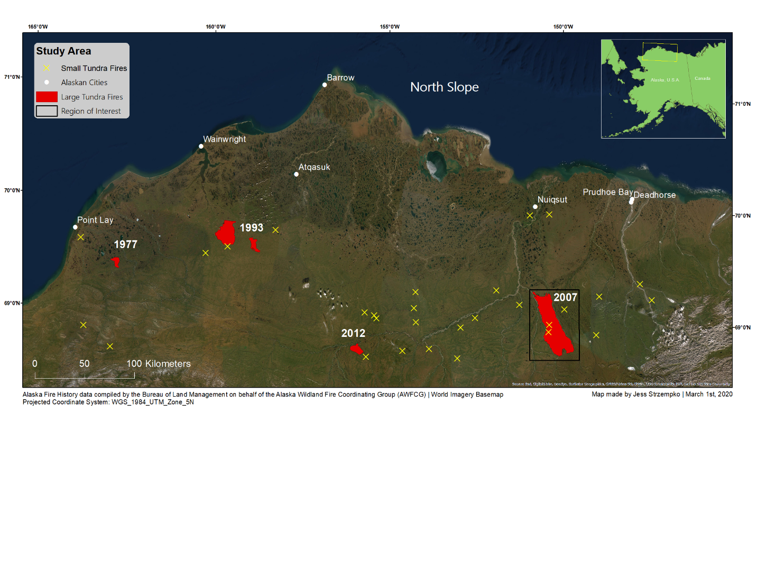

Figure 1. North Slope of Alaska with historical fire perimeters. Largest recorded fires since the 1950’s (polygons denoted in red) include: Kokolik River Fire (1977), Wainwright Fires (1993), Anaktuvuk River Fire (2007), and Kucher Creek Fire (2012). Yellow X’s used to denote small tundra fires (<1000 ha) since 1950’s.

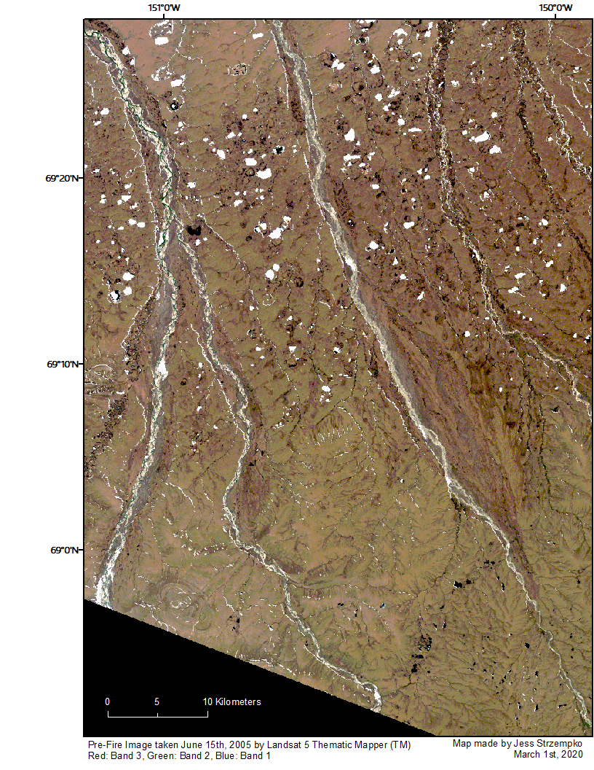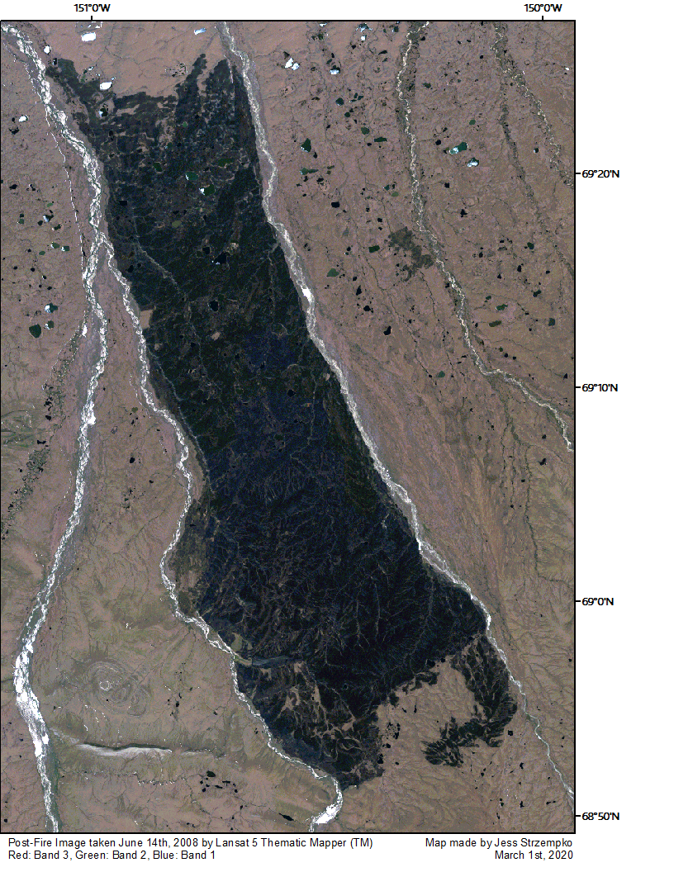

Figure 2. True color composites (R: 3, G: 2, B: 1) of the study area before (June 15th, 2005) and after (June 14th, 2008) the Anaktuvuk River Fire.

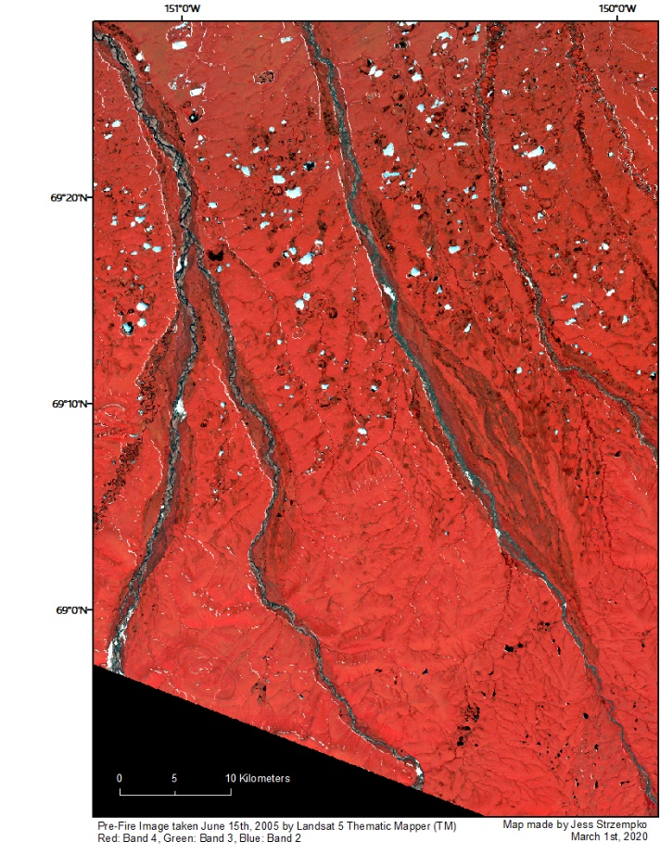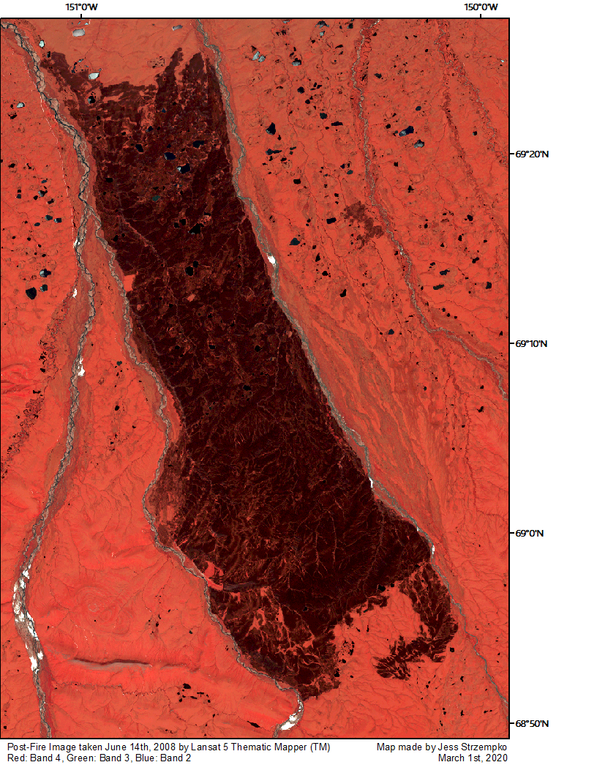

Figure 3. False color composites (R: 4, G: 3, B: 1) of the study area before (June 15th, 2005) and after (June 14th, 2008) the Anaktuvuk River Fire.

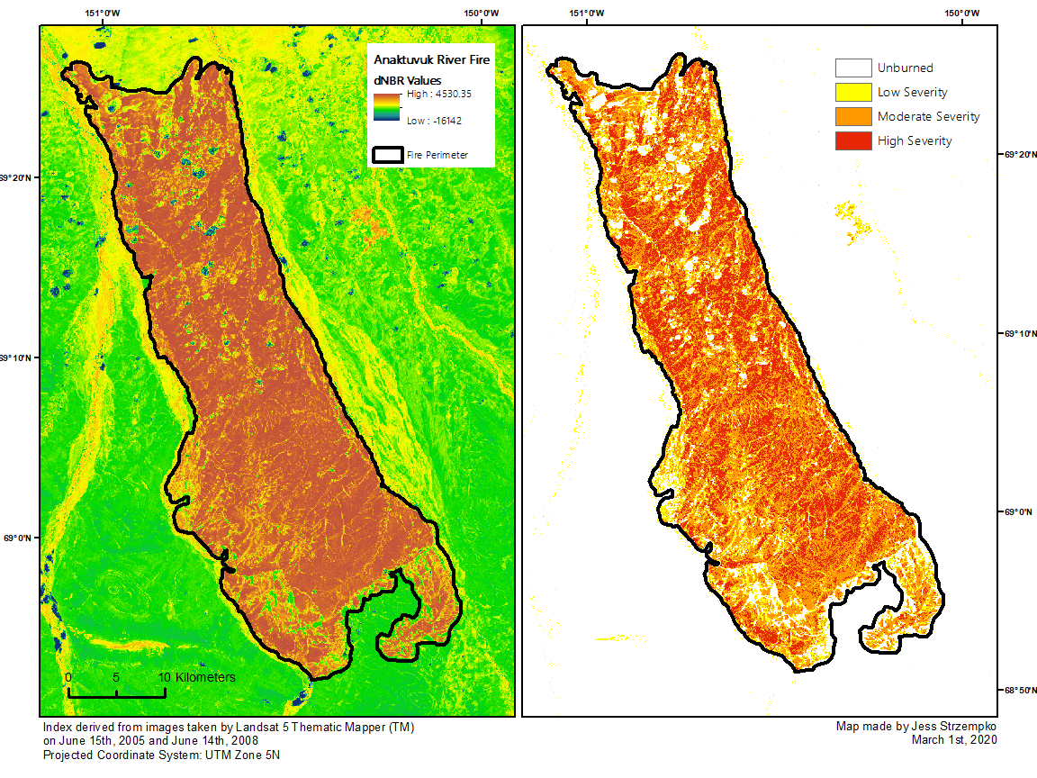

Figure 4. Differenced Normalized Burn Ratio (dNBR) using June 15th, 2005 pre-fire and June 14th, 2008 post-fire images. Value ranges are classified into severity classes on the right (derived from USGS designations in Table 2).

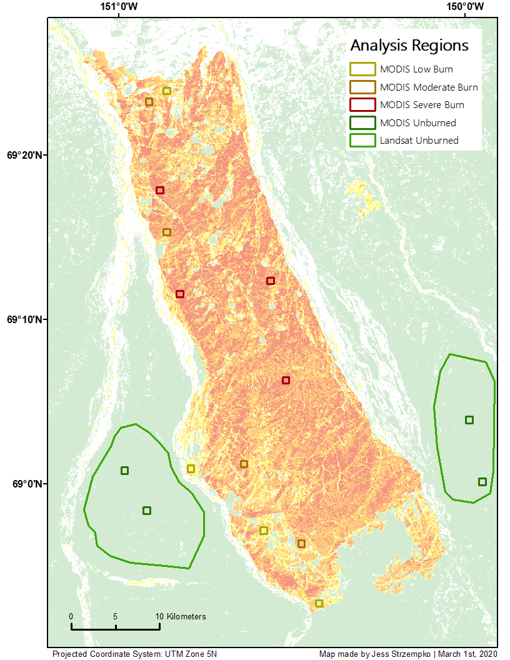

Figure 5. Regions chosen for Landsat and MODIS sample site analysis (low, moderate, and high burn severity regions and unburned).

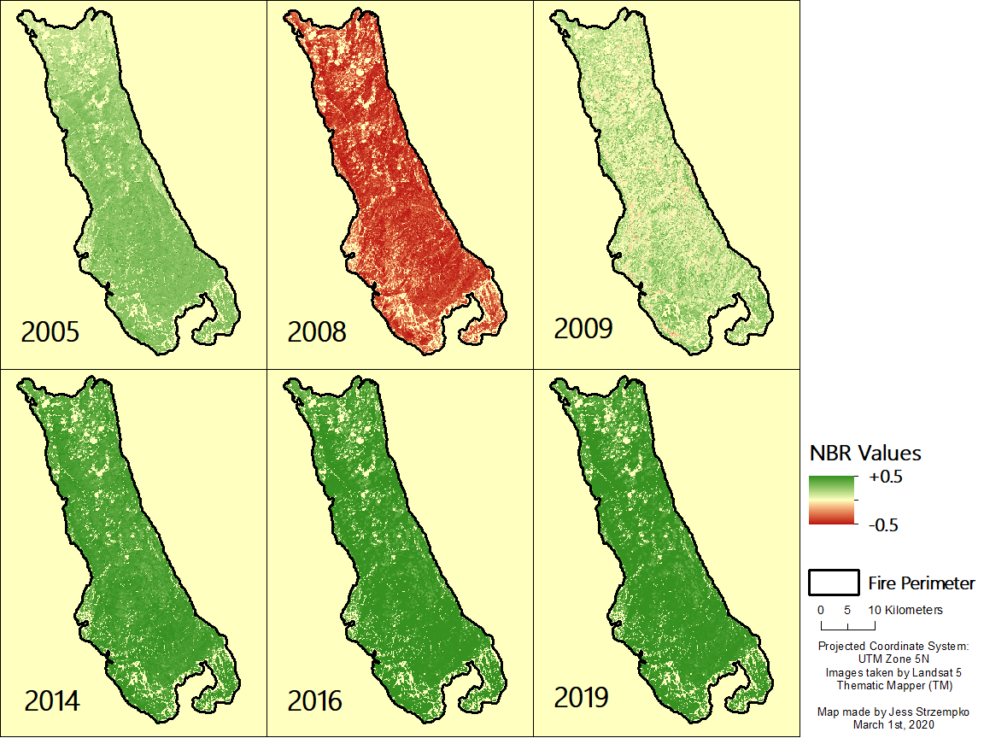

Figure 6. Landsat Normalized Burn Ratio values for all severity classes for 6 Landsat images (1 pre-fire and 5 post-fire). Negative NBR values indicate burn scars while positive NBR values indicate vegetation recovery.

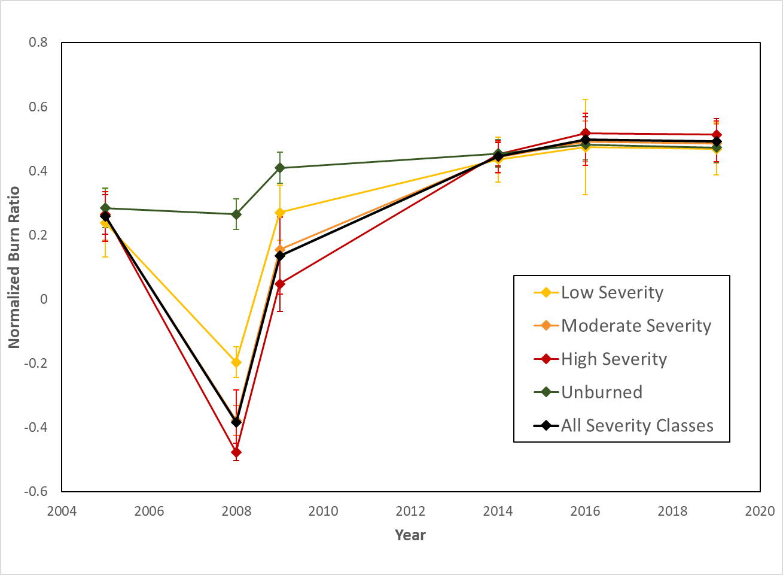

Figure 7. Landsat Normalized Burn Ratio values for all severity classes, separate severity classes, and unburned regions. Negative NBR values indicate burned vegetation while positive NBR values indicate vegetation recovery. Error bars indicate 1 standard deviation above and below the mean index value.

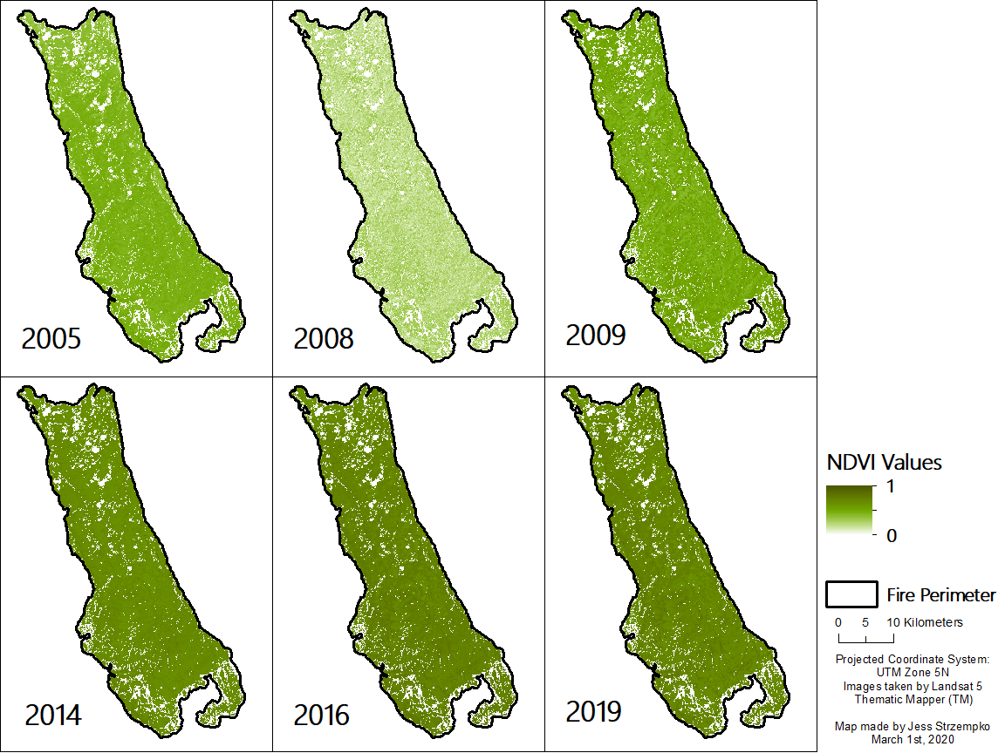

Figure 8. Normalized Difference Vegetation Index values for all severity classes for 6 Landsat images (1 pre-fire and 5 post-fire). NDVI values closer to 0 indicate less healthy vegetation while higher positive values closer to 1 indicate healthy vegetation.

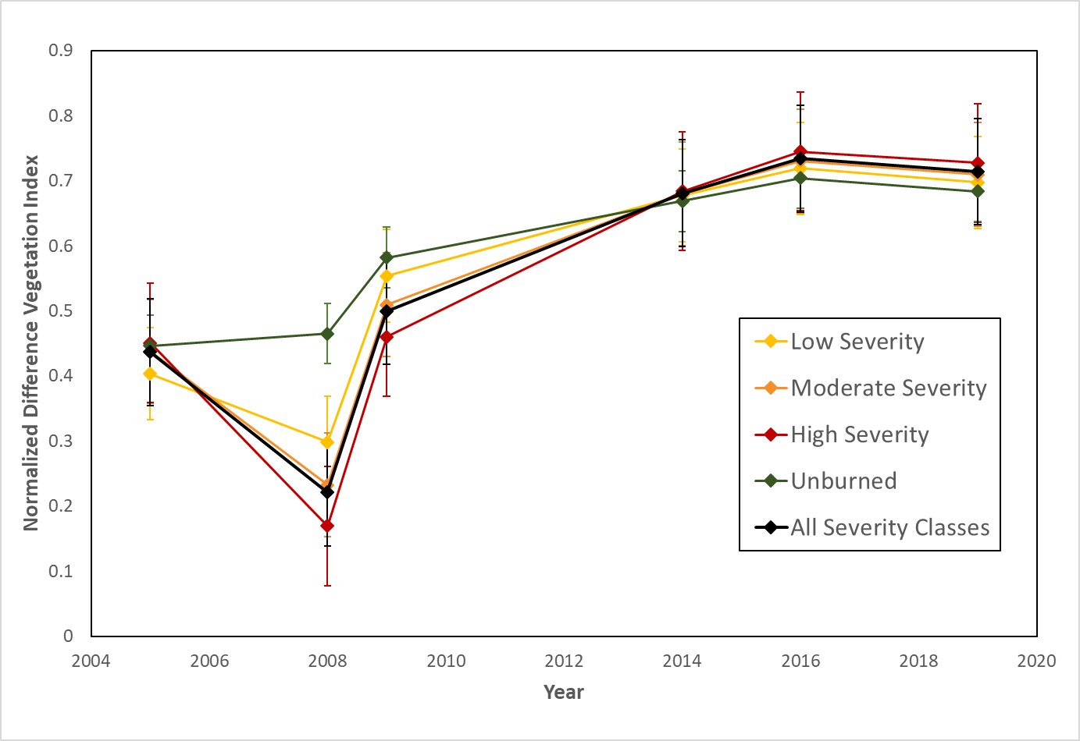

Figure 9. Landsat Normalized Difference Vegetation Index values for all severity classes, separate severity classes, and unburned regions. NDVI values closer to 0 indicate less healthy vegetation while higher positive values closer to 1 indicate healthy vegetation. Error bars indicate 1 standard deviation above and below the mean index value.

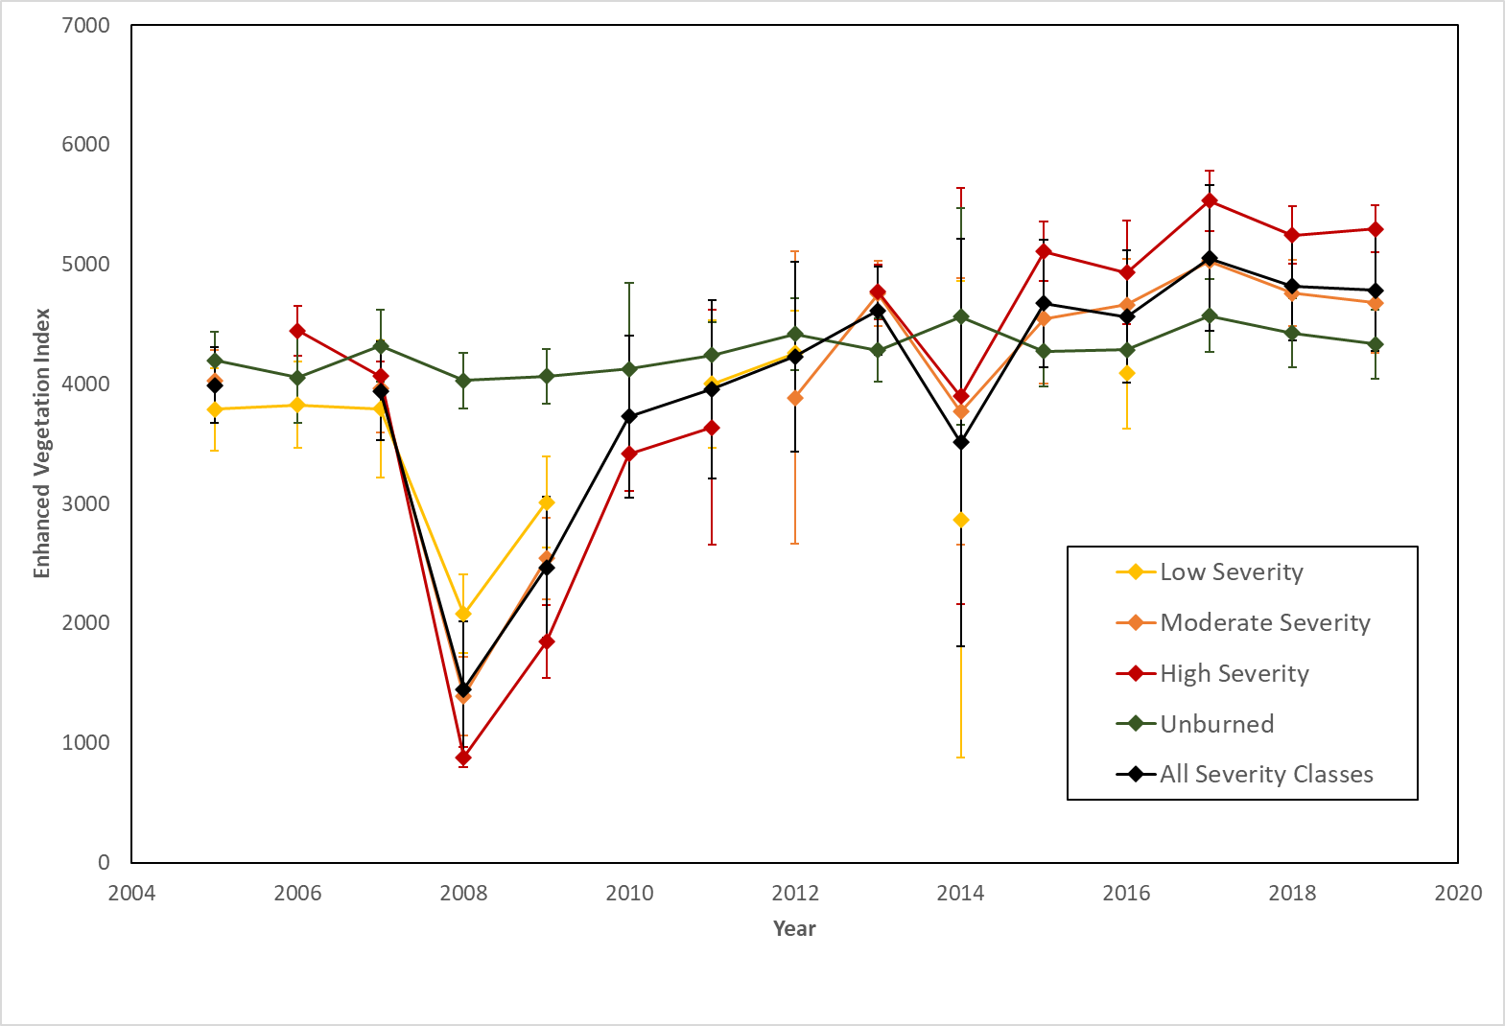

Figure 10. MODIS Enhanced Vegetation Index values for all severity classes, separate severity classes, and unburned regions. Higher positive values indicate healthier vegetation. Error bars indicate 1 standard deviation above and below the mean index value. Data points that displayed insignificance at α = 0.05 level were removed (according to t-tests run in Table 5).